


Getting a flu vaccine


Updated: March 2024

What you will find in here


Page number:

How people might feel when
they have the flu 2

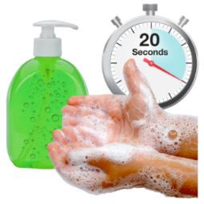
What to do if you are sick
with the flu ..4


Getting the flu vaccine 8

After having the flu vaccine 13


When you should not get the
flu vaccine 17

Getting the COVID-19 vaccine 18

How people might feel when they have the flu

The flu is a virus that can make some people very sick.
People with the flu may:

have a dry cough
have a headache
have body aches

have a runny nose.
have a sore throat
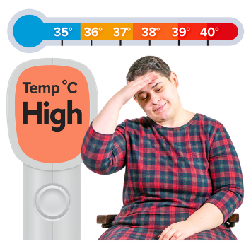
feel tired
feel really hot – this is also known as having a fever
sneeze a lot.
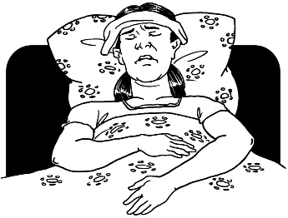
Some people can become very sick with the flu.

The flu can give you pneumonia.
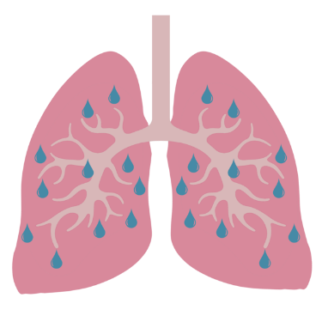

Pneumonia is an infection in your lungs.

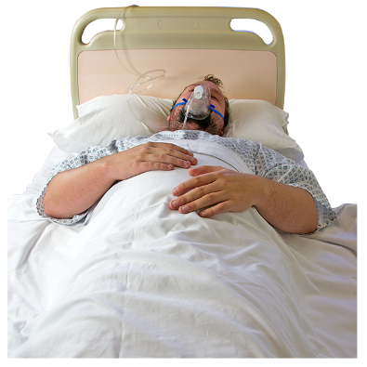
Sometimes people who are very sick with the flu need to go to hospital.

About 5 hundred people die from the flu every year.

What to do if you are sick with the flu

If you get sick with the flu you should clean your hands often with:
            - soap and water
            - hand sanitiser.

You should also stay home so that you do not give the flu to other people.

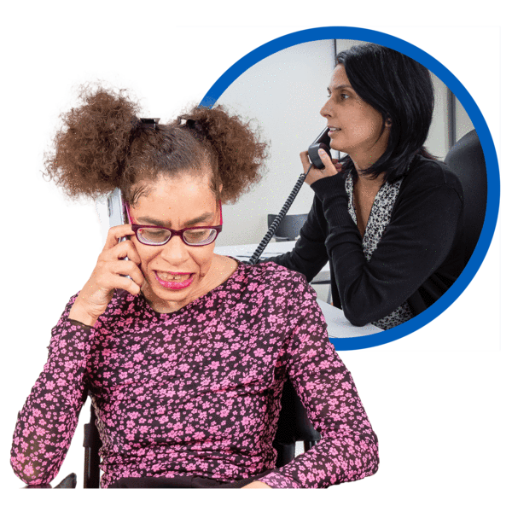
If you feel very sick you can call:
- your doctor

- Healthline for free on:
0800 611 116

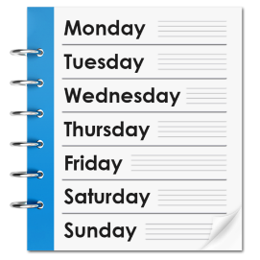
The Healthline phone line is open:



- every day
- all day and all night.


It does not cost any money to call the Healthline phone number.


You can also use the New Zealand Relay Service to call Healthline if you:
are Deaf / hearing impaired
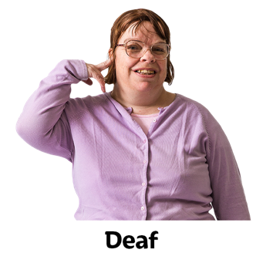
are deafblind
find it hard to speak.

You can find more information about the New Zealand Relay Service at their website:

www.nzrelay.co.nz
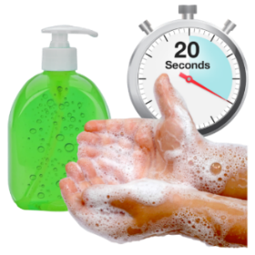
To help stop the spread of the flu you should:

wash your hands often
talk to your healthcare service about getting a flu vaccine.
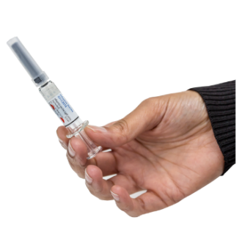
A vaccine helps your body make antibodies.
Antibodies help your body fight off sickness.
Most vaccines are an injection given in your arm.

Vaccines can help stop you from:
getting very sick
having to go to the hospital.

Getting a flu vaccine

Anyone over 6 months old can have a flu vaccine.


Most people aged over 9 years old need to have 1 flu vaccine each year to get good protection against flu.


If you have a child under 9 years old talk to your healthcare service.

They may need 1 or 2 flu vaccine depending on if they have had a flu vaccine before.


The best time to get your flu vaccine is before winter.

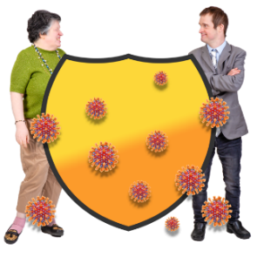
It takes around 2 weeks after your flu vaccine to be best protected.

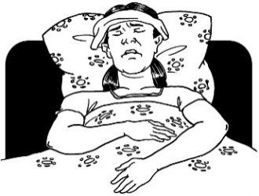
The flu vaccine is free for people who are most likely to get very sick.

The flu vaccine is free for:

tamariki / children 4 years and under who have:
- been in hospital for respiratory illness like bad asthma

- had respiratory illnesses for a long time
pregnant people.

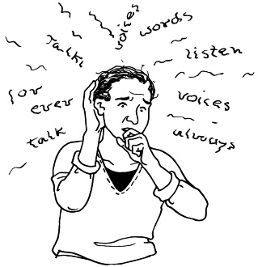
The flu vaccine is also free for:
people with mental illness such as schizophrenia

people aged 65 and over
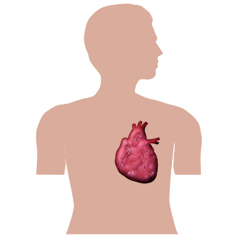
people with underlying health conditions including:
- heart disease
- cancer
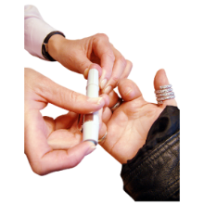
- diabetes
- bad asthma
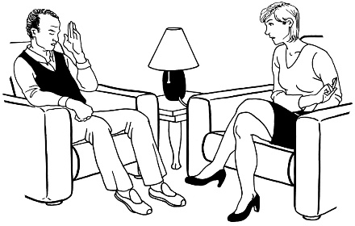
people accessing:
- mental health services
- addiction services.


You can get your free flu vaccine from:
your doctor

your healthcare service
some pharmacies.


Some employers may pay for your flu vaccine.

An employer is the
person / organisation:

you work for
who pays you money for the work you do.


You can check with your employer if they will pay the cost of your flu vaccine.

If you are not able to have a free flu vaccine you can still get a flu vaccine from:
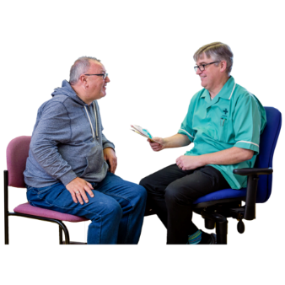
your doctor
your health care service
some pharmacies.




It will cost you between 25 dollars to 45 dollars for a flu vaccine.

You can talk to your health care service to:
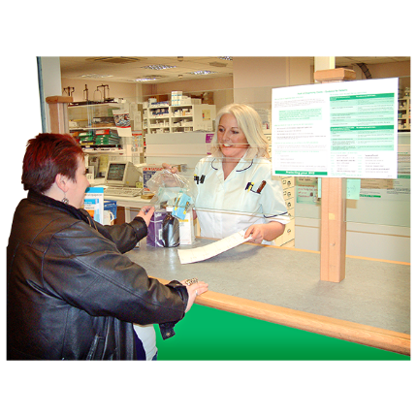
find out how much they charge for a flu vaccine
book in for your flu vaccine.

After having the flu vaccine
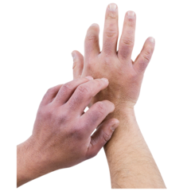
After getting the flu vaccine some people may have:

an allergic reaction
some side effects.

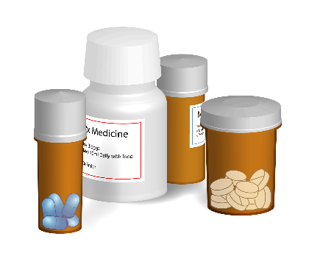
An allergic reaction is when someone has a bad reaction to something they have:

taken like some medicines or vaccines
eaten like nuts or fish.

Side-effects are ways the vaccine makes you feel unwell like:

a headache
feeling tired
a sore arm from the injection.


Staying for 20 minutes after your vaccine means the healthcare workers can make sure you:
are feeling ok
do not have any reactions.

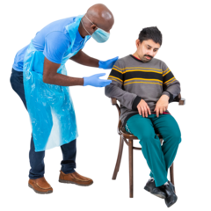
If you do have a reaction the person who gave you the vaccine is trained to look after you.

It is very unlikely anything serious will happen after getting the flu vaccine.

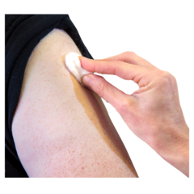
If you have a sore arm after having your flu vaccine you can put a cold cloth or ice pack on it to feel better.
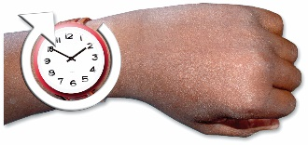
For most people side effects from the vaccine:
are not too bad
do not last long.

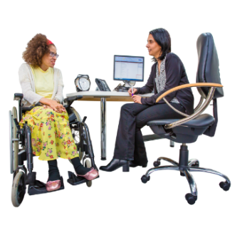
If you are worried about how you feel after your vaccine:
talk to your doctor
phone Healthline on:
0800 358 5453.


If you think you are very sick call 111 for an ambulance.

When you should not get a flu vaccine


You should not get your flu vaccine when you are unwell.

If you have had COVID-19 in the last 1 to 2 weeks you can have a flu jab as soon as you are feeling better.
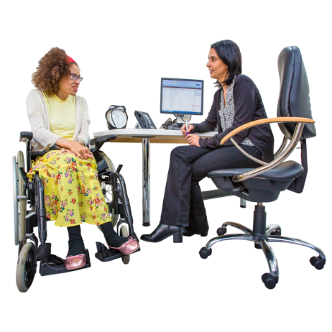

It is also important to talk to your healthcare service before getting the flu vaccine if you:
have had Guillain-Barre syndrome
are having cancer treatments
have had an allergic reaction to a vaccine before.

Getting the COVID-19 vaccine
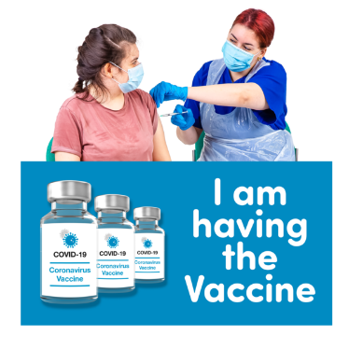

If you are due to have your
COVID-19 vaccine you can have this at the same time as your flu vaccine.


The COVID-19 vaccine is given to you in your arm.


The flu vaccine is given to you in the other arm.


This information is written by
Health New Zealand - Te Whatu Ora.


It has been translated into Easy Read by the Make it Easy Kia Māmā Mai service of People First New Zealand Ngā Tāngata Tuatahi.

The ideas in this document are not the ideas of People First New Zealand Ngā Tāngata Tuatahi.

Make it Easy uses images from:

- Changepeople.org

            - Photosymbols.com


- SGC Image Works
- Huriana Kopeke-Te Aho
- T. Wood.

All images used in this Easy Read document are subject to copyright rules and cannot be used without permission.

